Jonathan Lee

4-20-16

STA4853

FINAL PROJECT

For this project, I chose to analyze stock market closing prices of The Walt Disney Company. I found a data set on the Yahoo Finance website at <http://finance.yahoo.com>. My data set contained daily values for all days from April 1st, 2014 to April 1st, 2016 where values were given (weekdays that were not holidays). The values in particular that I was analyzing were the close prices listed for each day. Close prices for this set of data ranged from 77.01 to 121.69.

I acquired the daily growth return data by differencing the log of the close prices for each day, and when I plotted those values, there was some noticeable volatility in the graph. When we look at the ACF and the PACF graphs of the growth return data, we see that there is autocorrelation.

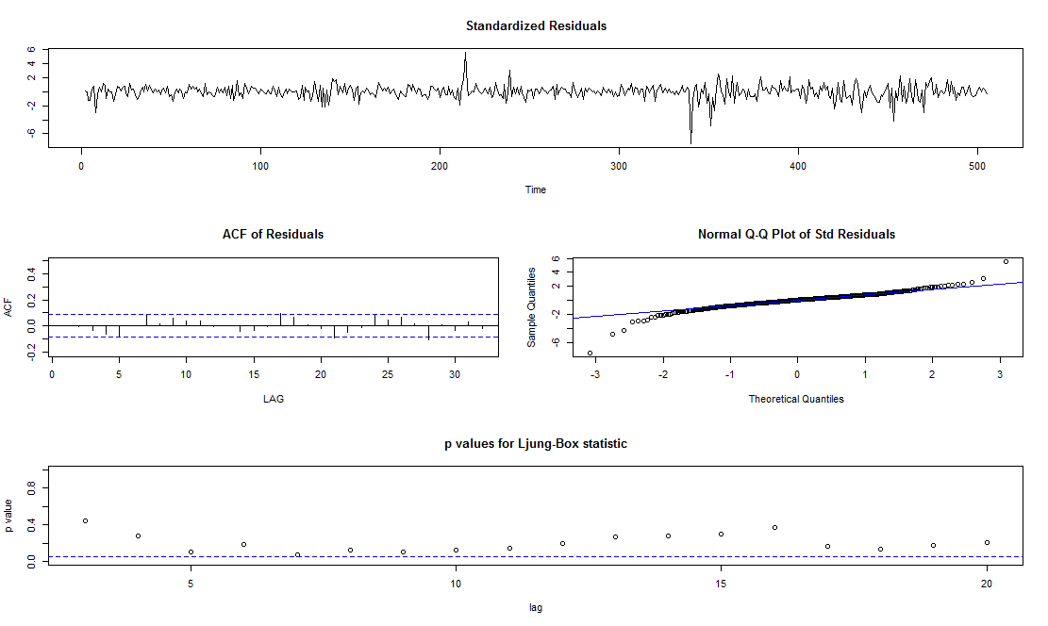 I attempted to fit three types of ARMA(p,q) models to this data set: an AR(1), an MA(1), and an ARMA(1,1), and I decided which model to use by looking at the standard errors of the AR(1) and MA(1) portions of each model. The standard error of AR(1) in the AR(1) model was 0.0445, of MA(1) in the MA(1) model was 0.0446, and of AR(1) and MA(1) in the ARMA(1,1) model were 0.7987 and 0.8018, respectively. The AR(1) and the MA(1) models both seemed like good fits, so I decided to use an AR(1) model.

Fitting the data as an AR(1) gave me the output seen to the right. The ACF and the p-values are within an acceptable range, but there is some noticeable volatility of the residuals and those residuals do not quite fit a normal distribution. When I ran the Ljung-Box Test on the residuals, the output was:

Box-Ljung test

data: r

X-squared = 12.62, df = 9, p-value = 0.1806

A p-value of 0.1806 would suggest that I may not need to model a GARCH component, but since that value is not overwhelmingly large, I would still consider modeling a GARCH component and see if I can create a good fit for the data.

I first tried modeling with a normal distribution, and I considered three different GARCH models: GARCH(1,1), GARCH(1,0), and GARCH(2,0). Modeling with GARCH(1,1) gave the following output: Error Analysis:

Estimate Std. Error t value Pr(>|t|)

mu 3.415e-04 5.363e-04 0.637 0.52436

ar1 -1.578e-02 5.659e-02 -0.279 0.78039

omega 2.469e-05 8.331e-06 2.964 0.00304 **

alpha1 1.421e-01 6.535e-02 2.175 0.02965 *

beta1 7.245e-01 8.947e-02 8.098 6.66e-16 ***

modeling with GARCH(1,0) gave this output: Error Analysis:

Estimate Std. Error t value Pr(>|t|)

mu 2.961e-04 5.856e-04 0.506 0.613

ar1 -2.331e-03 5.992e-02 -0.039 0.969

omega 1.604e-04 1.388e-05 11.561 <2e-16 ***

alpha1 4.831e-02 7.273e-02 0.664 0.507

and modeling with GARCH(2,0) printed this: Error Analysis:

Estimate Std. Error t value Pr(>|t|)

mu 1.542e-05 4.377e-04 0.035 0.972

ar1 6.191e-02 5.148e-02 1.203 0.229

omega 8.461e-05 1.164e-05 7.267 3.67e-13 ***

alpha1 8.633e-02 7.335e-02 1.177 0.239

alpha2 6.110e-01 1.391e-01 4.392 1.13e-05 ***

When looking at the p-values of the alpha and beta components of each model, GARCH(1,1) seems to be the best fit: we can see that for alpha1 and beta1, Pr(>|t|) is less than 0.05, suggesting that both components are significant. With GARCH(1,0), alpha1 is not significant since Pr(>|t|) = 0.507 and with GARCH(2,0), alpha1 is not significant since Pr(>|t|) = 0.239, suggesting that those models do not fit the data as well as GARCH(1,1).

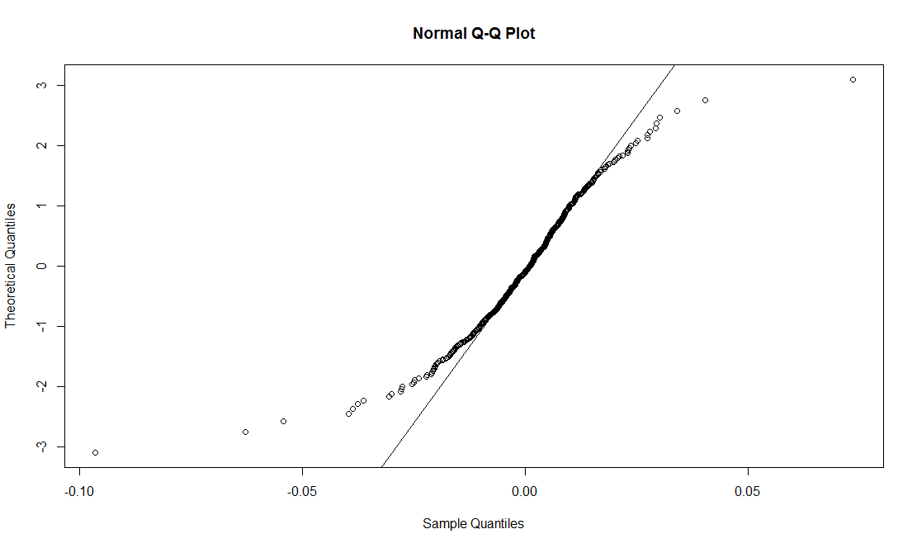 Having chosen to use an AR(1) component and a GARCH(1,1) component, I first attempted a model with a normal distribution of residuals. The normal Q-Q plot shows that the residuals cannot be fit well to a normal distribution. Additionally, the Standardized Residuals Tests indicate that we should not consider the residuals to be normally distributed:

Standardised Residuals Tests:

Statistic p-Value

Jarque-Bera Test R Chi^2 5414.291 0

Shapiro-Wilk Test R W 0.8953559 0

Ljung-Box Test R Q(10) 12.33449 0.263294

Ljung-Box Test R Q(15) 15.77142 0.3974037

Ljung-Box Test R Q(20) 21.65403 0.3595749

Ljung-Box Test R^2 Q(10) 0.8227066 0.9999302

Ljung-Box Test R^2 Q(15) 11.91063 0.6857805

Ljung-Box Test R^2 Q(20) 12.01946 0.9154047

LM Arch Test R TR^2 11.0757 0.5224423

A p-value of near zero for the Jarque-Bera Test highly suggest that this time series does not have the skewness and the kurtosis of a normal distribution, whereas a p-value of near zero for the Shapiro-Wilk Test tells us that this data fails a test of normality.

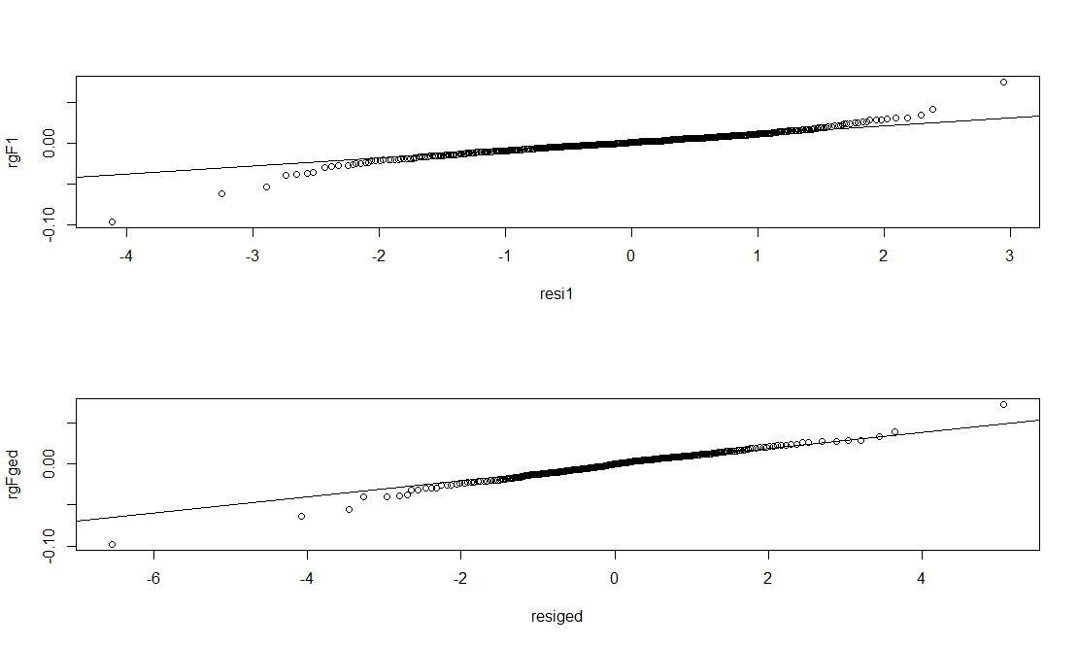 I then considered a skew normal distribution and a generalized error distribution. The model with a skew normal distribution gave a skewness parameter of approximately 0.7777, and the model with a generalized error distribution gave a shape parameter of approximately 1.0785. However, we can see from the Q-Q plots that neither of these distributions portray the distribution of the residuals well.

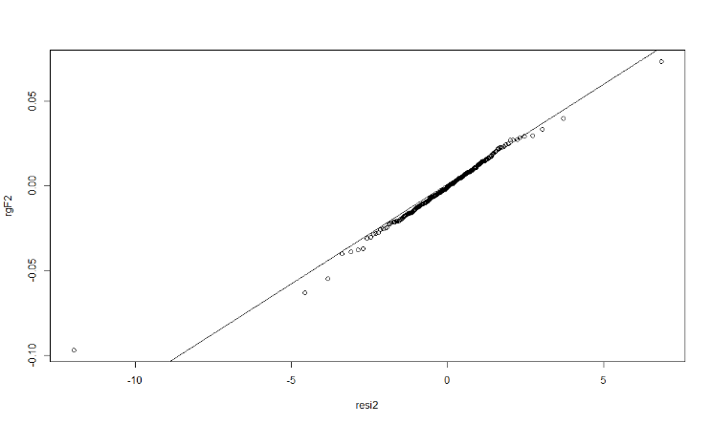 The distribution that seemed to be the best fit for the data was the skew student t distribution. Fitted to this data, the model had a shape parameter of approximately 3.7929 and a skewness parameter of approximately 0.8730. The Q-Q plot seen here seems to be the best one of all of the distributions that I have tried, so I will choose to predict future values with this distribution.

The R output for the summary of this model gives these coefficients for the model: Coefficient(s):

mu ar1 omega alpha1 beta1

8.5767e-04 -2.4029e-02 8.3123e-06 1.1223e-01 8.5633e-01

Which suggests that our model can be written as xt ≈ 0.0009 - 0.002xt-1 + ϵt, where with yt = (xt – xt-1)/(xt-1), we have that σ2t ≈ 0.000008 + (0.112 + 0.856)(yt-1)2 + νt + 0.856 νt-1.

When I run the predict function with this model, I get these values for the difference of the log of the predicted values for the next five days: [1] 0.0009158121 0.0008356647 0.0008375906 0.0008375443 0.0008375454. To back transform these values to daily close values, I ran this code which resulted in the following values: > c=rep(0,5)

> c=predict(gF2,n.ahead=5,trace=FALSE,plot=FALSE)$meanForecast

> wd_vol_pred=c(wd_vol,c)

> wd_ts_log=c(log(wd_ts[1]),log(wd_ts[1])+cumsum(wd_vol_pred))

> wd_ts_pred=exp(wd_ts_log)

> y_hat=wd_ts_pred[(length(wd_ts_pred)-4):(length(wd_ts_pred))]

> y_hat

[1] 99.16077 99.24367 99.32683 99.41006 99.49335

The Yahoo finance gave the following values as the actual close values for the following five days (April 4th to April 8th): [1] 98.68 97.00 97.48 96.16 96.42, and the correlation between these values and the predicted values is approximately -0.849. It seems that my model did not properly predict the trend: the model predicted the daily values to slowly increase, when in reality, they decreased overall.

APPENDIX

> wd <- read.csv("C:/Users/Jonathan!/Desktop/SCHOOL THINGS!!!/STA4853/wd.csv")

> wd$Date <- strptime(wd$Date,format="%m/%d/%y")

> format(wd$Date,format="%Y-%m-%d")

> wd=wd[order(wd$Date),]

> wd_ts=ts(wd$Close,frequency=1)

> plot.ts(wd_ts,xy.labels=TRUE)

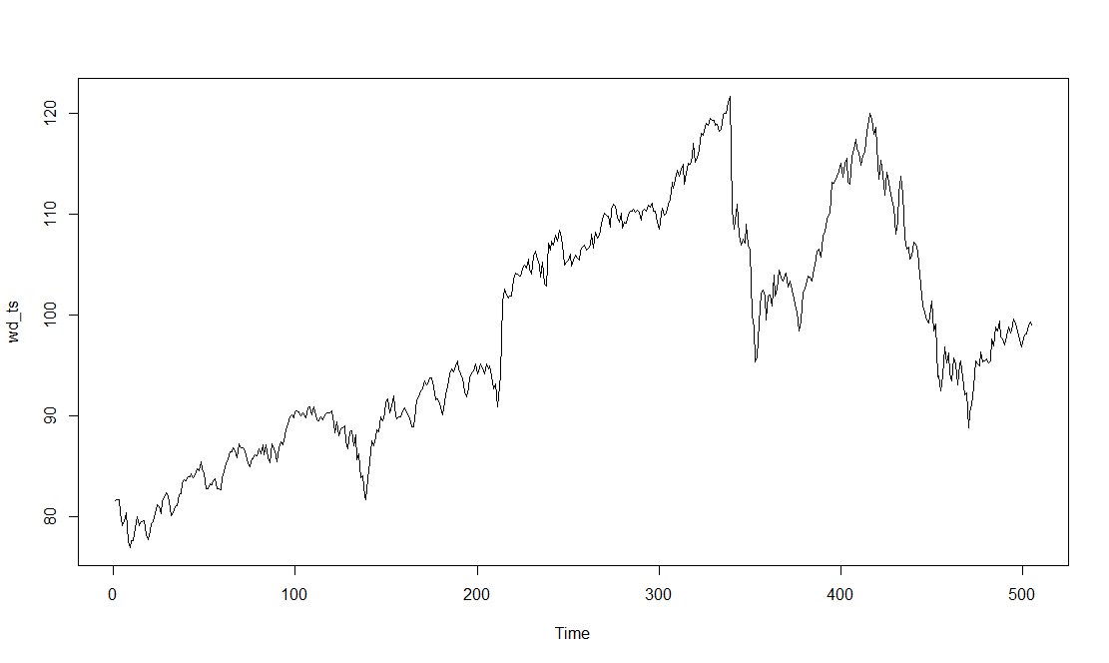

> acf2(wd_ts)

ACF PACF

[1,] 0.99 0.99

[2,] 0.98 -0.03

[3,] 0.97 0.01

[4,] 0.96 0.00

[5,] 0.96 0.02

[6,] 0.95 0.07

[7,] 0.94 0.00

[8,] 0.93 -0.12

[9,] 0.92 -0.03

[10,] 0.91 -0.05

[11,] 0.90 -0.03

[12,] 0.89 -0.04

[13,] 0.88 0.00

[14,] 0.87 -0.04

[15,] 0.85 0.04

[16,] 0.84 0.03

[17,] 0.83 0.00

[18,] 0.82 -0.09

[19,] 0.81 -0.06

[20,] 0.80 0.00

[21,] 0.78 0.03

[22,] 0.77 0.07

[23,] 0.76 0.03

[24,] 0.75 0.01

[25,] 0.74 -0.06

[26,] 0.73 -0.03

[27,] 0.72 -0.02

[28,] 0.71 -0.01

[29,] 0.70 0.08

[30,] 0.69 -0.03

[31,] 0.68 -0.02

[32,] 0.66 -0.05

[33,] 0.65 0.01

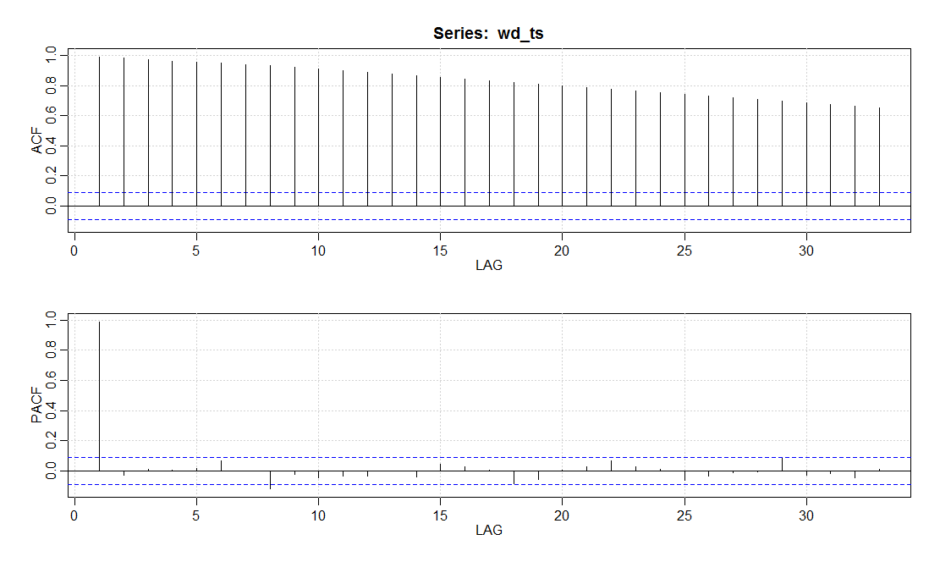

> wd_vol=diff(log(wd_ts))

> plot.ts(wd_vol)

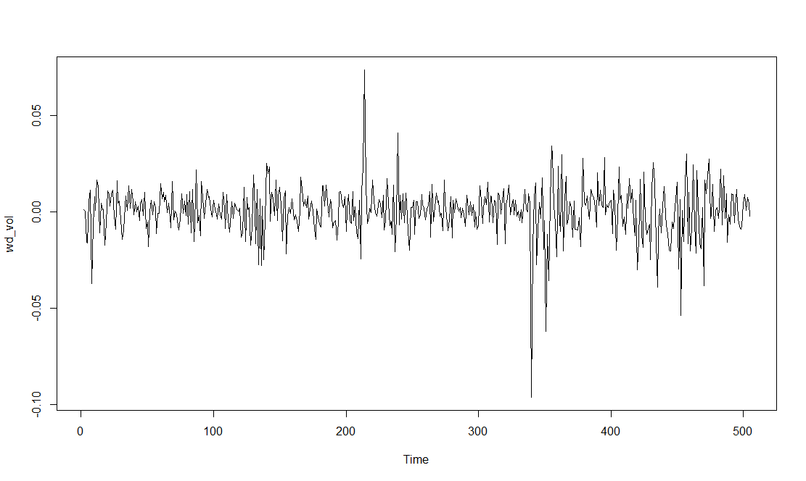

> par(mfrow=c(2,1))

> acf(wd_vol)

> pacf(wd_vol)

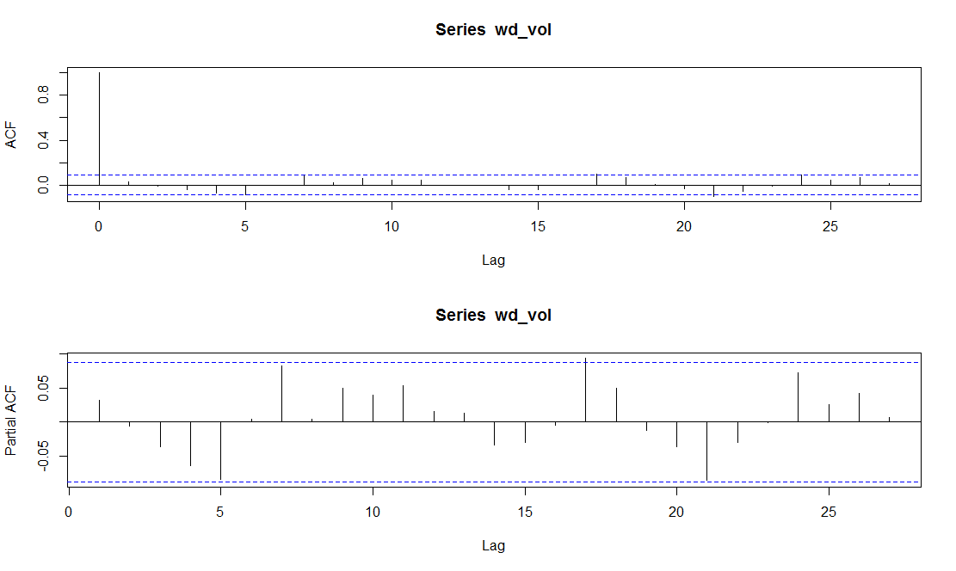

> model1=sarima(wd_vol,1,0,0); model1

initial value -4.345327

iter 2 value -4.345833

iter 2 value -4.345833

iter 2 value -4.345833

final value -4.345833

converged

initial value -4.346821

iter 1 value -4.346821

final value -4.346821

converged

$fit

Call:

stats::arima(x = xdata, order = c(p, d, q), seasonal = list(order = c(P, D,

Q), period = S), xreg = xmean, include.mean = FALSE, optim.control = list(trace = trc,

REPORT = 1, reltol = tol))

Coefficients:

ar1 xmean

0.0318 4e-04

s.e. 0.0445 6e-04

sigma^2 estimated as 0.0001676: log likelihood = 1475.65, aic = -2945.31

$AIC

[1] -7.685708

$AICc

[1] -7.681644

$BIC

[1] -8.668952

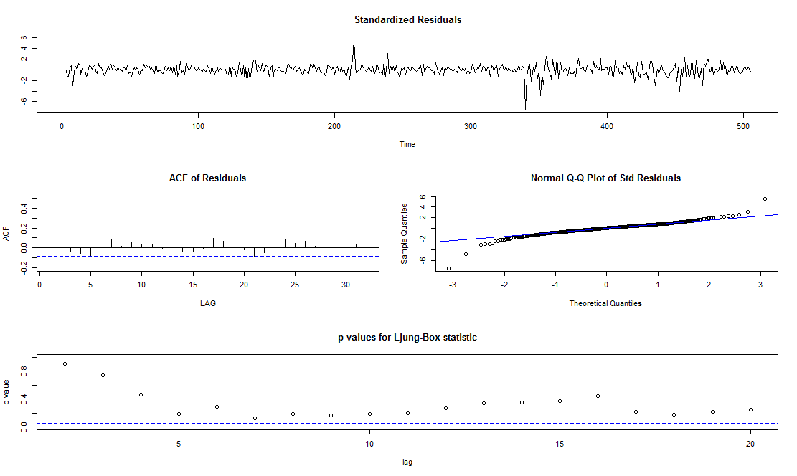

> model2=sarima(wd_vol,0,0,1); model2

initial value -4.346315

iter 2 value -4.346827

iter 2 value -4.346827

iter 2 value -4.346827

final value -4.346827

converged

initial value -4.346826

iter 1 value -4.346826

final value -4.346826

converged

$fit

Call:

stats::arima(x = xdata, order = c(p, d, q), seasonal = list(order = c(P, D,

Q), period = S), xreg = xmean, include.mean = FALSE, optim.control = list(trace = trc,

REPORT = 1, reltol = tol))

Coefficients:

ma1 xmean

0.0320 4e-04

s.e. 0.0446 6e-04

sigma^2 estimated as 0.0001676: log likelihood = 1475.66, aic = -2945.31

$AIC

[1] -7.685717

$AICc

[1] -7.681654

$BIC

[1] -8.668961

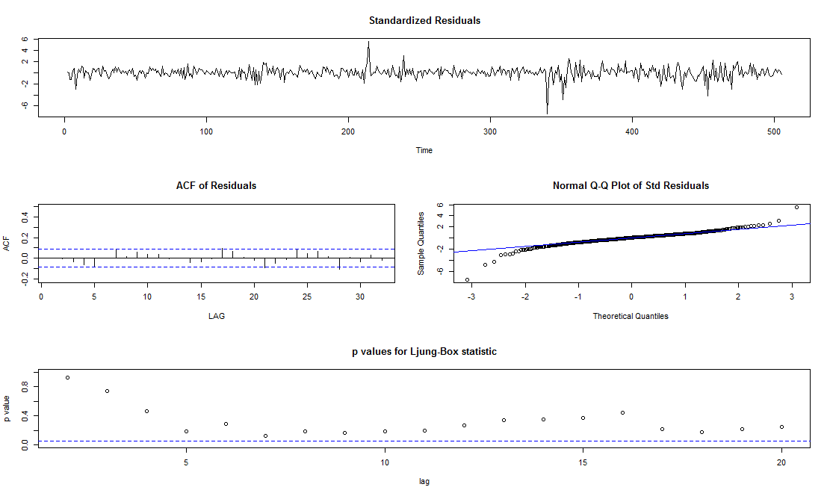

> model3=sarima(wd_vol,1,0,1); model3

initial value -4.345327

iter 2 value -4.345337

iter 3 value -4.345836

iter 3 value -4.345836

iter 3 value -4.345836

final value -4.345836

converged

initial value -4.346824

iter 1 value -4.346824

final value -4.346824

converged

$fit

Call:

stats::arima(x = xdata, order = c(p, d, q), seasonal = list(order = c(P, D,

Q), period = S), xreg = xmean, include.mean = FALSE, optim.control = list(trace = trc,

REPORT = 1, reltol = tol))

Coefficients:

ar1 ma1 xmean

0.0156 0.0162 4e-04

s.e. 0.7989 0.8018 6e-04

sigma^2 estimated as 0.0001676: log likelihood = 1475.65, aic = -2943.31

$AIC

[1] -7.681745

$AICc

[1] -7.677618

$BIC

[1] -8.656611



> r=residuals(model1$fit)

> par(mfrow=c(1,1))

> hist(r)

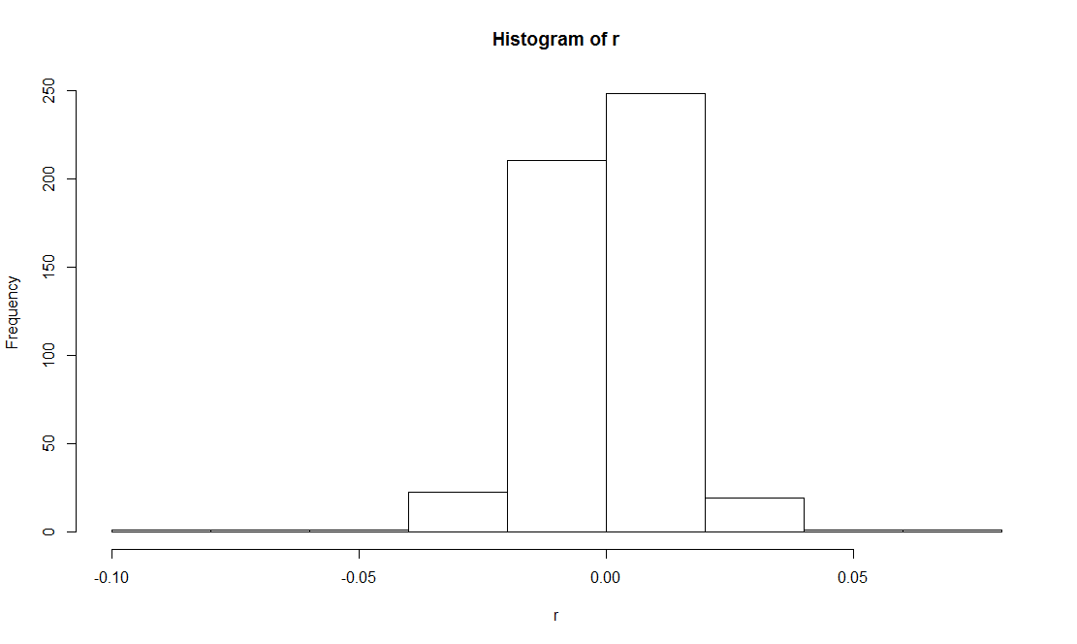

> pacf(r)

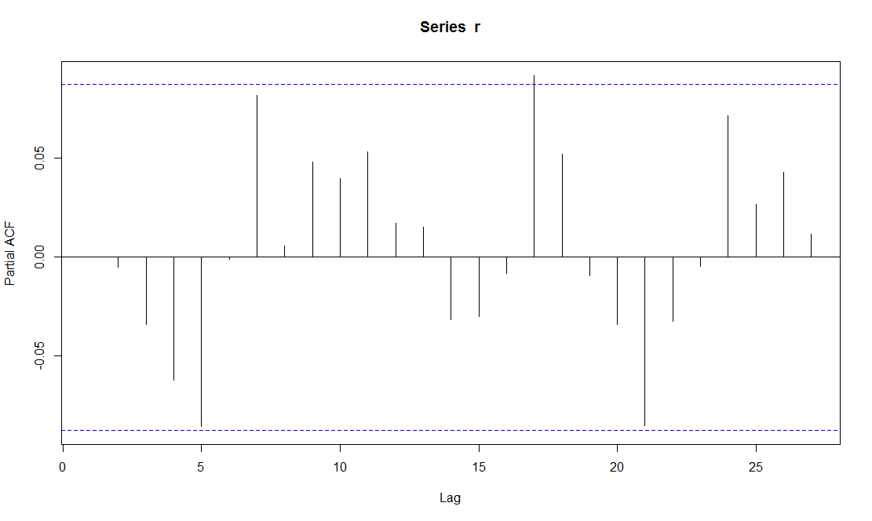

> Box.test(r,10,type="Ljung-Box",fitdf=1)

Box-Ljung test

data: r

X-squared = 12.62, df = 9, p-value = 0.1806

> r2=r^2

> acf2(r2)

ACF PACF

[1,] 0.01 0.01

[2,] 0.07 0.07

[3,] 0.03 0.03

[4,] 0.08 0.08

[5,] 0.02 0.02

[6,] 0.00 -0.01

[7,] 0.00 0.00

[8,] 0.02 0.02

[9,] 0.04 0.03

[10,] -0.01 -0.01

[11,] 0.23 0.22

[12,] 0.01 0.01

[13,] 0.07 0.04

[14,] -0.02 -0.03

[15,] 0.06 0.02

[16,] 0.02 0.01

[17,] 0.01 0.00

[18,] 0.00 0.01

[19,] 0.02 0.01

[20,] 0.03 0.01

[21,] 0.00 0.00

[22,] -0.02 -0.08

[23,] 0.04 0.04

[24,] 0.00 -0.02

[25,] 0.03 0.04

[26,] 0.02 0.01

[27,] -0.03 -0.04

[28,] -0.01 -0.02

[29,] -0.02 -0.03

[30,] -0.02 -0.02

[31,] -0.01 -0.01

[32,] -0.02 -0.02

[33,] 0.00 0.03

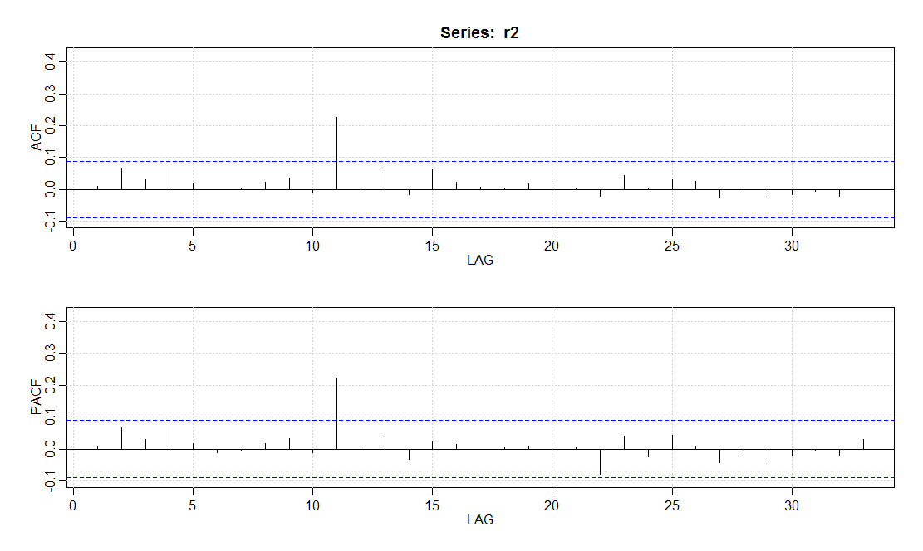

> gF.1=garchFit(~arma(1,0)+garch(1,1),wd_vol,cond.dist="norm")

Series Initialization:

ARMA Model: arma

Formula Mean: ~ arma(1, 0)

GARCH Model: garch

Formula Variance: ~ garch(1, 1)

ARMA Order: 1 0

Max ARMA Order: 1

GARCH Order: 1 1

Max GARCH Order: 1

Maximum Order: 1

Conditional Dist: norm

h.start: 2

llh.start: 1

Length of Series: 504

Recursion Init: mci

Series Scale: 0.01296733

Parameter Initialization:

Initial Parameters: $params

Limits of Transformations: $U, $V

Which Parameters are Fixed? $includes

Parameter Matrix:

U V params includes

mu -0.29739753 0.2973975 0.02973039 TRUE

ar1 -0.99999999 1.0000000 0.03176384 TRUE

omega 0.00000100 100.0000000 0.10000000 TRUE

alpha1 0.00000001 1.0000000 0.10000000 TRUE

gamma1 -0.99999999 1.0000000 0.10000000 FALSE

beta1 0.00000001 1.0000000 0.80000000 TRUE

delta 0.00000000 2.0000000 2.00000000 FALSE

skew 0.10000000 10.0000000 1.00000000 FALSE

shape 1.00000000 10.0000000 4.00000000 FALSE

Index List of Parameters to be Optimized:

mu ar1 omega alpha1 beta1

1 2 3 4 6

Persistence: 0.9

--- START OF TRACE ---

Selected Algorithm: nlminb

R coded nlminb Solver:

0: 697.72221: 0.0297304 0.0317638 0.100000 0.100000 0.800000

1: 697.52219: 0.0297303 0.0308698 0.104143 0.101205 0.802059

2: 697.43016: 0.0297302 0.0283757 0.105557 0.0984950 0.799215

3: 697.35387: 0.0297303 0.0220244 0.112841 0.0989164 0.798193

4: 697.16299: 0.0297310 0.0150627 0.111786 0.100355 0.791638

5: 697.07697: 0.0297319 0.00850893 0.114747 0.105571 0.787675

6: 696.93418: 0.0297341 0.00449280 0.121807 0.111880 0.771162

7: 696.89501: 0.0297245 0.00785481 0.134451 0.118359 0.758309

8: 696.79934: 0.0297073 -0.00508312 0.131121 0.130306 0.750764

9: 696.78590: 0.0297069 -0.00602947 0.131773 0.128539 0.749085

10: 696.77583: 0.0297021 -0.00789439 0.133292 0.128286 0.750263

11: 696.76436: 0.0296867 -0.00962785 0.133511 0.128186 0.748281

12: 696.75530: 0.0296720 -0.00835082 0.136204 0.130834 0.744689

13: 696.73492: 0.0295504 -0.0130852 0.139085 0.134932 0.737481

14: 696.73439: 0.0295152 -0.0146014 0.139800 0.134450 0.738421

15: 696.73116: 0.0294802 -0.0136015 0.140178 0.134890 0.736805

16: 696.72885: 0.0294132 -0.0125635 0.142855 0.135842 0.734143

17: 696.72654: 0.0291614 -0.0161491 0.143173 0.135146 0.733721

18: 696.72539: 0.0289060 -0.0158110 0.143331 0.136975 0.730886

19: 696.72163: 0.0286429 -0.0159024 0.144506 0.138756 0.729319

20: 696.71951: 0.0275566 -0.0158303 0.146470 0.141709 0.725143

21: 696.71908: 0.0265508 -0.0156964 0.147079 0.142106 0.724340

22: 696.71904: 0.0263549 -0.0158464 0.146927 0.142224 0.724368

23: 696.71904: 0.0263282 -0.0157668 0.146842 0.142118 0.724524

24: 696.71904: 0.0263321 -0.0157785 0.146838 0.142111 0.724534

Final Estimate of the Negative LLH:

LLH: -1493.323 norm LLH: -2.962943

mu ar1 omega alpha1 beta1

3.414574e-04 -1.577849e-02 2.469105e-05 1.421110e-01 7.245339e-01

R-optimhess Difference Approximated Hessian Matrix:

mu ar1 omega alpha1 beta1

mu -3750065.677 -3994.76770 6.299140e+07 -5.487765e+03 6.117233e+03

ar1 -3994.768 -327.61053 4.391753e+05 -5.520737e+01 2.933576e+01

omega 62991404.955 439175.32430 -1.709123e+11 -1.419975e+07 -2.357218e+07

alpha1 -5487.765 -55.20737 -1.419975e+07 -2.256504e+03 -2.631126e+03

beta1 6117.233 29.33576 -2.357218e+07 -2.631126e+03 -3.802602e+03

attr(,"time")

Time difference of 0.0312531 secs

--- END OF TRACE ---

Time to Estimate Parameters:

Time difference of 0.1406372 secs

> summary(gF.1)

Title:

GARCH Modelling

Call:

garchFit(formula = ~arma(1, 0) + garch(1, 1), data = wd_vol,

cond.dist = "norm")

Mean and Variance Equation:

data ~ arma(1, 0) + garch(1, 1)

<environment: 0x0000000012b13e30>

[data = wd_vol]

Conditional Distribution:

norm

Coefficient(s):

mu ar1 omega alpha1 beta1

3.4146e-04 -1.5778e-02 2.4691e-05 1.4211e-01 7.2453e-01

Std. Errors:

based on Hessian

Error Analysis:

Estimate Std. Error t value Pr(>|t|)

mu 3.415e-04 5.363e-04 0.637 0.52436

ar1 -1.578e-02 5.659e-02 -0.279 0.78039

omega 2.469e-05 8.331e-06 2.964 0.00304 **

alpha1 1.421e-01 6.535e-02 2.175 0.02965 *

beta1 7.245e-01 8.947e-02 8.098 6.66e-16 ***

---

Signif. codes: 0 ・**・0.001 ・*・0.01 ・・0.05 ・・0.1 ・・1

Log Likelihood:

1493.323 normalized: 2.962943

Description:

Fri Apr 22 20:54:10 2016 by user: Jonathan!

Standardised Residuals Tests:

Statistic p-Value

Jarque-Bera Test R Chi^2 5414.291 0

Shapiro-Wilk Test R W 0.8953559 0

Ljung-Box Test R Q(10) 12.33449 0.263294

Ljung-Box Test R Q(15) 15.77142 0.3974037

Ljung-Box Test R Q(20) 21.65403 0.3595749

Ljung-Box Test R^2 Q(10) 0.8227066 0.9999302

Ljung-Box Test R^2 Q(15) 11.91063 0.6857805

Ljung-Box Test R^2 Q(20) 12.01946 0.9154047

LM Arch Test R TR^2 11.0757 0.5224423

Information Criterion Statistics:

AIC BIC SIC HQIC

-5.906045 -5.864155 -5.906240 -5.889613

> gF.2=garchFit(~arma(1,0)+garch(1,0),wd_vol,cond.dist="norm")

Series Initialization:

ARMA Model: arma

Formula Mean: ~ arma(1, 0)

GARCH Model: garch

Formula Variance: ~ garch(1, 0)

ARMA Order: 1 0

Max ARMA Order: 1

GARCH Order: 1 0

Max GARCH Order: 1

Maximum Order: 1

Conditional Dist: norm

h.start: 2

llh.start: 1

Length of Series: 504

Recursion Init: mci

Series Scale: 0.01296733

Parameter Initialization:

Initial Parameters: $params

Limits of Transformations: $U, $V

Which Parameters are Fixed? $includes

Parameter Matrix:

U V params includes

mu -0.29739753 0.2973975 0.02973039 TRUE

ar1 -0.99999999 1.0000000 0.03176384 TRUE

omega 0.00000100 100.0000000 0.10000000 TRUE

alpha1 0.00000001 1.0000000 0.10000000 TRUE

gamma1 -0.99999999 1.0000000 0.10000000 FALSE

delta 0.00000000 2.0000000 2.00000000 FALSE

skew 0.10000000 10.0000000 1.00000000 FALSE

shape 1.00000000 10.0000000 4.00000000 FALSE

Index List of Parameters to be Optimized:

mu ar1 omega alpha1

1 2 3 4

Persistence: 0.1

--- START OF TRACE ---

Selected Algorithm: nlminb

R coded nlminb Solver:

0: 1728.6092: 0.0297304 0.0317638 0.100000 0.100000

1: 725.05905: 0.0297123 0.0186317 1.07150 0.336656

2: 721.57028: 0.0296733 -0.0390232 1.09084 0.232487

3: 715.64707: 0.0296203 -0.0142096 0.926959 1.00000e-08

4: 715.55014: 0.0296205 0.0221990 0.957794 0.142068

5: 714.75999: 0.0295834 -0.00434453 0.888310 0.133080

6: 714.36548: 0.0295466 -0.0438885 0.910184 0.0733204

7: 714.10968: 0.0290350 0.00215644 0.964898 0.0589957

8: 714.09746: 0.0270679 0.00197506 0.974744 0.0251883

9: 714.03740: 0.0251192 -0.00138942 0.946745 0.0481340

10: 714.03130: 0.0247102 -0.00341037 0.956400 0.0495691

11: 714.02897: 0.0238899 -0.00214013 0.954268 0.0481811

12: 714.02873: 0.0232716 -0.00227627 0.953948 0.0481233

13: 714.02868: 0.0228636 -0.00228803 0.954013 0.0482177

14: 714.02868: 0.0228348 -0.00233745 0.953997 0.0483027

15: 714.02868: 0.0228348 -0.00233134 0.953997 0.0483139

Final Estimate of the Negative LLH:

LLH: -1476.014 norm LLH: -2.928599

mu ar1 omega alpha1

0.0002961064 -0.0023313423 0.0001604161 0.0483138786

R-optimhess Difference Approximated Hessian Matrix:

mu ar1 omega alpha1

mu -3030610.791 -2301.5460 1841011.4 -5179.2765

ar1 -2301.546 -377.2360 50240.4 -154.8573

omega 1841011.409 50240.3993 -9087575859.3 -1110538.9274

alpha1 -5179.276 -154.8573 -1110538.9 -400.0007

attr(,"time")

Time difference of 0.04987192 secs

--- END OF TRACE ---

Time to Estimate Parameters:

Time difference of 0.1123769 secs

> summary(gF.2)

Title:

GARCH Modelling

Call:

garchFit(formula = ~arma(1, 0) + garch(1, 0), data = wd_vol,

cond.dist = "norm")

Mean and Variance Equation:

data ~ arma(1, 0) + garch(1, 0)

<environment: 0x00000000104f2418>

[data = wd_vol]

Conditional Distribution:

norm

Coefficient(s):

mu ar1 omega alpha1

0.00029611 -0.00233134 0.00016042 0.04831388

Std. Errors:

based on Hessian

Error Analysis:

Estimate Std. Error t value Pr(>|t|)

mu 2.961e-04 5.856e-04 0.506 0.613

ar1 -2.331e-03 5.992e-02 -0.039 0.969

omega 1.604e-04 1.388e-05 11.561 <2e-16 ***

alpha1 4.831e-02 7.273e-02 0.664 0.507

---

Signif. codes: 0 ・**・0.001 ・*・0.01 ・・0.05 ・・0.1 ・・1

Log Likelihood:

1476.014 normalized: 2.928599

Description:

Fri Apr 22 20:54:11 2016 by user: Jonathan!

Standardised Residuals Tests:

Statistic p-Value

Jarque-Bera Test R Chi^2 1944.751 0

Shapiro-Wilk Test R W 0.9116068 0

Ljung-Box Test R Q(10) 13.29421 0.2076844

Ljung-Box Test R Q(15) 15.97062 0.3840069

Ljung-Box Test R Q(20) 24.01359 0.2417991

Ljung-Box Test R^2 Q(10) 6.588125 0.7636718

Ljung-Box Test R^2 Q(15) 40.42357 0.0003912901

Ljung-Box Test R^2 Q(20) 41.03812 0.003683473

LM Arch Test R TR^2 33.33994 0.0008565265

Information Criterion Statistics:

AIC BIC SIC HQIC

-5.841325 -5.807812 -5.841449 -5.828179

> gF.3=garchFit(~arma(1,0)+garch(2,0),wd_vol,cond.dist="norm")

Series Initialization:

ARMA Model: arma

Formula Mean: ~ arma(1, 0)

GARCH Model: garch

Formula Variance: ~ garch(2, 0)

ARMA Order: 1 0

Max ARMA Order: 1

GARCH Order: 2 0

Max GARCH Order: 2

Maximum Order: 2

Conditional Dist: norm

h.start: 3

llh.start: 1

Length of Series: 504

Recursion Init: mci

Series Scale: 0.01296733

Parameter Initialization:

Initial Parameters: $params

Limits of Transformations: $U, $V

Which Parameters are Fixed? $includes

Parameter Matrix:

U V params includes

mu -0.29739753 0.2973975 0.02973039 TRUE

ar1 -0.99999999 1.0000000 0.03176384 TRUE

omega 0.00000100 100.0000000 0.10000000 TRUE

alpha1 0.00000001 1.0000000 0.05000000 TRUE

alpha2 0.00000001 1.0000000 0.05000000 TRUE

gamma1 -0.99999999 1.0000000 0.10000000 FALSE

gamma2 -0.99999999 1.0000000 0.10000000 FALSE

delta 0.00000000 2.0000000 2.00000000 FALSE

skew 0.10000000 10.0000000 1.00000000 FALSE

shape 1.00000000 10.0000000 4.00000000 FALSE

Index List of Parameters to be Optimized:

mu ar1 omega alpha1 alpha2

1 2 3 4 5

Persistence: 0.1

--- START OF TRACE ---

Selected Algorithm: nlminb

R coded nlminb Solver:

0: 1422.6094: 0.0297304 0.0317638 0.100000 0.0500000 0.0500000

1: 718.68092: 0.0297202 0.0266825 0.900509 0.376984 0.552237

2: 713.50078: 0.0296429 -0.106272 0.815877 0.0421907 0.888492

3: 700.78431: 0.0268533 0.154499 0.691223 1.00000e-08 1.00000

4: 697.12828: 0.0158052 0.110068 0.646594 1.00000e-08 1.00000

5: 692.61885: -0.00942690 0.0758163 0.458651 1.00000e-08 1.00000

6: 691.55917: -0.0193510 0.0398697 0.409349 0.103389 0.941097

7: 690.96628: -0.0192950 0.0973143 0.446740 0.101874 0.892330

8: 690.15059: -0.0211741 0.0727252 0.439778 0.0828161 0.846792

9: 689.56269: -0.0210413 0.0651371 0.483649 0.0730531 0.776191

10: 689.42114: -0.0227340 0.0791904 0.458918 0.0642968 0.721813

11: 689.20176: -0.0248452 0.0737512 0.487689 0.0874925 0.696383

12: 689.11066: -0.0256045 0.0788602 0.494347 0.0899401 0.616672

13: 689.04086: -0.0233014 0.0486073 0.500515 0.0786838 0.618831

14: 688.92599: -0.0208326 0.0613020 0.504304 0.0825857 0.618638

15: 688.78354: -0.00727853 0.0676487 0.512173 0.0656754 0.614598

16: 688.71018: 0.000846504 0.0638284 0.500549 0.0859003 0.611671

17: 688.70798: 0.00117040 0.0622797 0.502948 0.0859453 0.612627

18: 688.70790: 0.00117727 0.0618928 0.503188 0.0863254 0.610873

19: 688.70790: 0.00118913 0.0619103 0.503164 0.0863275 0.610967

20: 688.70790: 0.00118903 0.0619103 0.503163 0.0863293 0.610967

Final Estimate of the Negative LLH:

LLH: -1501.335 norm LLH: -2.978839

mu ar1 omega alpha1 alpha2

1.541850e-05 6.191034e-02 8.460771e-05 8.632930e-02 6.109672e-01

R-optimhess Difference Approximated Hessian Matrix:

mu ar1 omega alpha1 alpha2

mu -5335314.0875 582.40238 2.430526e+07 1.619098e+03 -949.45262

ar1 582.4024 -488.75887 -8.877676e+04 -1.567158e+02 20.20994

omega 24305256.5003 -88776.76298 -1.568743e+10 -1.461549e+06 -718540.68304

alpha1 1619.0983 -156.71577 -1.461549e+06 -3.738135e+02 -78.56835

alpha2 -949.4526 20.20994 -7.185407e+05 -7.856835e+01 -88.38939

attr(,"time")

Time difference of 0.03125 secs

--- END OF TRACE ---

Time to Estimate Parameters:

Time difference of 0.143261 secs

> summary(gF.3)

Title:

GARCH Modelling

Call:

garchFit(formula = ~arma(1, 0) + garch(2, 0), data = wd_vol,

cond.dist = "norm")

Mean and Variance Equation:

data ~ arma(1, 0) + garch(2, 0)

<environment: 0x0000000014397768>

[data = wd_vol]

Conditional Distribution:

norm

Coefficient(s):

mu ar1 omega alpha1 alpha2

1.5418e-05 6.1910e-02 8.4608e-05 8.6329e-02 6.1097e-01

Std. Errors:

based on Hessian

Error Analysis:

Estimate Std. Error t value Pr(>|t|)

mu 1.542e-05 4.377e-04 0.035 0.972

ar1 6.191e-02 5.148e-02 1.203 0.229

omega 8.461e-05 1.164e-05 7.267 3.67e-13 ***

alpha1 8.633e-02 7.335e-02 1.177 0.239

alpha2 6.110e-01 1.391e-01 4.392 1.13e-05 ***

---

Signif. codes: 0 ・**・0.001 ・*・0.01 ・・0.05 ・・0.1 ・・1

Log Likelihood:

1501.335 normalized: 2.978839

Description:

Fri Apr 22 20:54:12 2016 by user: Jonathan!

Standardised Residuals Tests:

Statistic p-Value

Jarque-Bera Test R Chi^2 2119.862 0

Shapiro-Wilk Test R W 0.928311 8.526535e-15

Ljung-Box Test R Q(10) 14.8177 0.1388509

Ljung-Box Test R Q(15) 17.81151 0.2727045

Ljung-Box Test R Q(20) 22.91192 0.2931401

Ljung-Box Test R^2 Q(10) 3.145066 0.977801

Ljung-Box Test R^2 Q(15) 9.115363 0.8714086

Ljung-Box Test R^2 Q(20) 12.42165 0.9007993

LM Arch Test R TR^2 8.402898 0.7529062

Information Criterion Statistics:

AIC BIC SIC HQIC

-5.937836 -5.895945 -5.938030 -5.921404

> gF=gF.1

> rgF=residuals(gF)

> hist(rgF)

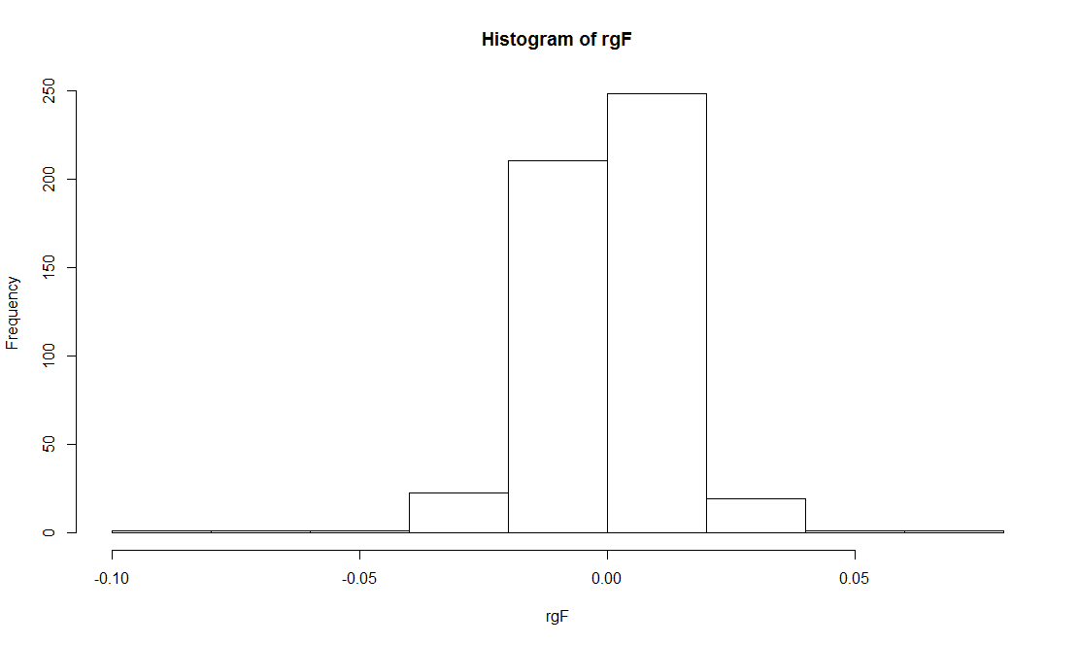

> qqnorm(rgF,datax=TRUE)

> qqline(rgF,datax=TRUE)



> gF1=garchFit(~arma(1,0)+garch(1,1),wd_vol,cond.dist="snorm")

Series Initialization:

ARMA Model: arma

Formula Mean: ~ arma(1, 0)

GARCH Model: garch

Formula Variance: ~ garch(1, 1)

ARMA Order: 1 0

Max ARMA Order: 1

GARCH Order: 1 1

Max GARCH Order: 1

Maximum Order: 1

Conditional Dist: snorm

h.start: 2

llh.start: 1

Length of Series: 504

Recursion Init: mci

Series Scale: 0.01296733

Parameter Initialization:

Initial Parameters: $params

Limits of Transformations: $U, $V

Which Parameters are Fixed? $includes

Parameter Matrix:

U V params includes

mu -0.29739753 0.2973975 0.02973039 TRUE

ar1 -0.99999999 1.0000000 0.03176384 TRUE

omega 0.00000100 100.0000000 0.10000000 TRUE

alpha1 0.00000001 1.0000000 0.10000000 TRUE

gamma1 -0.99999999 1.0000000 0.10000000 FALSE

beta1 0.00000001 1.0000000 0.80000000 TRUE

delta 0.00000000 2.0000000 2.00000000 FALSE

skew 0.10000000 10.0000000 1.00000000 TRUE

shape 1.00000000 10.0000000 4.00000000 FALSE

Index List of Parameters to be Optimized:

mu ar1 omega alpha1 beta1 skew

1 2 3 4 6 8

Persistence: 0.9

--- START OF TRACE ---

Selected Algorithm: nlminb

R coded nlminb Solver:

0: 697.72221: 0.0297304 0.0317638 0.100000 0.100000 0.800000 1.00000

1: 696.65860: 0.0297302 0.0291481 0.112121 0.103525 0.806024 0.982362

2: 694.27956: 0.0297300 0.0266526 0.105160 0.0959633 0.794828 0.965737

3: 691.29615: 0.0297290 0.0202881 0.115998 0.101373 0.795924 0.922541

4: 688.01368: 0.0297184 0.00766190 0.0928661 0.115965 0.772245 0.840390

5: 684.96283: 0.0296862 -0.00814506 0.128217 0.173732 0.724153 0.807730

6: 684.37206: 0.0295488 -0.0349003 0.149415 0.212153 0.650666 0.795315

7: 684.12130: 0.0294773 -0.0334406 0.144935 0.230860 0.656382 0.790480

8: 684.11478: 0.0291595 -0.0274723 0.144455 0.222627 0.659333 0.776076

9: 684.10472: 0.0291553 -0.0278268 0.145216 0.223736 0.660349 0.777076

10: 684.09811: 0.0291487 -0.0283162 0.143904 0.223953 0.659676 0.778292

11: 684.09021: 0.0290908 -0.0304416 0.143543 0.226174 0.661213 0.778771

12: 684.08436: 0.0290048 -0.0326737 0.142009 0.225955 0.660793 0.778945

13: 684.07920: 0.0288913 -0.0329655 0.142938 0.226245 0.660901 0.779541

14: 684.07359: 0.0286784 -0.0304947 0.142791 0.227856 0.659179 0.780475

15: 684.06069: 0.0282030 -0.0344061 0.144054 0.226163 0.658686 0.781758

16: 684.05995: 0.0281991 -0.0343766 0.144235 0.226557 0.658955 0.781804

17: 684.05940: 0.0281928 -0.0343298 0.143849 0.226780 0.658772 0.781843

18: 684.05844: 0.0281660 -0.0344446 0.143920 0.227264 0.659006 0.781825

19: 684.03976: 0.0269961 -0.0411348 0.140534 0.230644 0.659935 0.780097

20: 683.80689: 0.00786397 -0.0378379 0.149775 0.239211 0.639813 0.782242

21: 683.71959: 0.00262133 -0.0324294 0.142582 0.224316 0.661841 0.783279

22: 683.68509: -0.000210820 -0.0339680 0.146913 0.238137 0.652499 0.778081

23: 683.67433: -0.00309057 -0.0311200 0.144327 0.239072 0.654082 0.777147

24: 683.67389: -0.00395683 -0.0315861 0.143811 0.239276 0.654371 0.778039

25: 683.67382: -0.00389802 -0.0314489 0.143822 0.239059 0.654443 0.777588

26: 683.67382: -0.00383802 -0.0314078 0.143845 0.239085 0.654425 0.777661

27: 683.67381: -0.00385115 -0.0314232 0.143842 0.239085 0.654424 0.777660

28: 683.67381: -0.00385067 -0.0314219 0.143842 0.239085 0.654425 0.777660

Final Estimate of the Negative LLH:

LLH: -1506.369 norm LLH: -2.988827

mu ar1 omega alpha1 beta1 skew

-4.993295e-05 -3.142189e-02 2.418727e-05 2.390846e-01 6.544249e-01 7.776596e-01

R-optimhess Difference Approximated Hessian Matrix:

mu ar1 omega alpha1 beta1

mu -4.705100e+06 -3951.028825 -1.162206e+08 -1.604947e+04 -2.085207e+04

ar1 -3.951029e+03 -327.685909 6.251140e+05 -5.078687e+01 4.327861e+01

omega -1.162206e+08 625114.049983 -1.395963e+11 -1.000589e+07 -1.810749e+07

alpha1 -1.604947e+04 -50.786869 -1.000589e+07 -1.284216e+03 -1.724169e+03

beta1 -2.085207e+04 43.278608 -1.810749e+07 -1.724169e+03 -2.861254e+03

skew 2.564292e+03 -4.442523 -2.000127e+05 -1.876150e+02 -1.223295e+02

skew

mu 2.564292e+03

ar1 -4.442523e+00

omega -2.000127e+05

alpha1 -1.876150e+02

beta1 -1.223295e+02

skew -7.526912e+02

attr(,"time")

Time difference of 0.05507994 secs

--- END OF TRACE ---

Time to Estimate Parameters:

Time difference of 0.2063909 secs

> summary(gF1)

Title:

GARCH Modelling

Call:

garchFit(formula = ~arma(1, 0) + garch(1, 1), data = wd_vol,

cond.dist = "snorm")

Mean and Variance Equation:

data ~ arma(1, 0) + garch(1, 1)

<environment: 0x00000000102db588>

[data = wd_vol]

Conditional Distribution:

snorm

Coefficient(s):

mu ar1 omega alpha1 beta1 skew

-4.9933e-05 -3.1422e-02 2.4187e-05 2.3908e-01 6.5442e-01 7.7766e-01

Std. Errors:

based on Hessian

Error Analysis:

Estimate Std. Error t value Pr(>|t|)

mu -4.993e-05 4.747e-04 -0.105 0.916233

ar1 -3.142e-02 5.778e-02 -0.544 0.586587

omega 2.419e-05 6.803e-06 3.555 0.000378 ***

alpha1 2.391e-01 7.327e-02 3.263 0.001102 **

beta1 6.544e-01 7.326e-02 8.933 < 2e-16 ***

skew 7.777e-01 3.820e-02 20.359 < 2e-16 ***

---

Signif. codes: 0 ・**・0.001 ・*・0.01 ・・0.05 ・・0.1 ・・1

Log Likelihood:

1506.369 normalized: 2.988827

Description:

Fri Apr 22 20:55:16 2016 by user: Jonathan!

Standardised Residuals Tests:

Statistic p-Value

Jarque-Bera Test R Chi^2 6690.299 0

Shapiro-Wilk Test R W 0.8913595 0

Ljung-Box Test R Q(10) 12.69296 0.2413492

Ljung-Box Test R Q(15) 16.58588 0.344217

Ljung-Box Test R Q(20) 21.87417 0.3473773

Ljung-Box Test R^2 Q(10) 0.9313568 0.9998759

Ljung-Box Test R^2 Q(15) 12.23232 0.661366

Ljung-Box Test R^2 Q(20) 12.32686 0.9043665

LM Arch Test R TR^2 11.39507 0.4953983

Information Criterion Statistics:

AIC BIC SIC HQIC

-5.953844 -5.903575 -5.954123 -5.934125

> rgF1=residuals(gF1)

> set.seed(6737181)

> resi1=rsnorm(5000,xi=0.7777)

> qqplot(resi1,rgF1)

> qqline(rgF1,distribution=qsnorm)

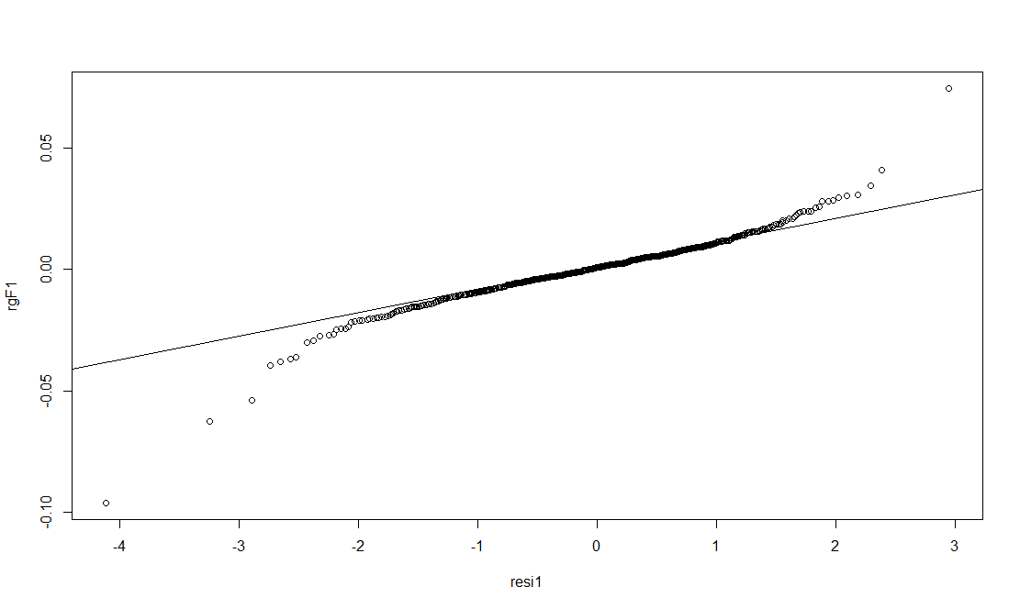

> gedFit(rgF1)

$par

mean sd nu

0.001325915 0.012532340 1.078527005

$objective

[1] -1519.822

$convergence

[1] 0

$iterations

[1] 20

$evaluations

function gradient

43 80

$message

[1] "relative convergence (4)"

Warning messages:

1: In nlminb(start = start, objective = loglik, lower = c(-Inf, 0, :

NA/NaN function evaluation

2: In nlminb(start = start, objective = loglik, lower = c(-Inf, 0, :

NA/NaN function evaluation

> n=gedFit(rgF1)$par[3]; n

Warning messages:

1: In nlminb(start = start, objective = loglik, lower = c(-Inf, 0, :

NA/NaN function evaluation

2: In nlminb(start = start, objective = loglik, lower = c(-Inf, 0, :

NA/NaN function evaluation

nu

1.078527

> gFged=garchFit(~arma(1,0)+garch(1,1),wd_vol,cond.dist="ged",shape=n,include.shape=FALSE)

Series Initialization:

ARMA Model: arma

Formula Mean: ~ arma(1, 0)

GARCH Model: garch

Formula Variance: ~ garch(1, 1)

ARMA Order: 1 0

Max ARMA Order: 1

GARCH Order: 1 1

Max GARCH Order: 1

Maximum Order: 1

Conditional Dist: ged

h.start: 2

llh.start: 1

Length of Series: 504

Recursion Init: mci

Series Scale: 0.01296733

Parameter Initialization:

Initial Parameters: $params

Limits of Transformations: $U, $V

Which Parameters are Fixed? $includes

Parameter Matrix:

U V params includes

mu -0.29739753 0.2973975 0.02973039 TRUE

ar1 -0.99999999 1.0000000 0.03176384 TRUE

omega 0.00000100 100.0000000 0.10000000 TRUE

alpha1 0.00000001 1.0000000 0.10000000 TRUE

gamma1 -0.99999999 1.0000000 0.10000000 FALSE

beta1 0.00000001 1.0000000 0.80000000 TRUE

delta 0.00000000 2.0000000 2.00000000 FALSE

skew 0.10000000 10.0000000 1.00000000 FALSE

shape 1.00000000 10.0000000 1.07852700 FALSE

Index List of Parameters to be Optimized:

mu ar1 omega alpha1 beta1

1 2 3 4 6

Persistence: 0.9

--- START OF TRACE ---

Selected Algorithm: nlminb

R coded nlminb Solver:

0: 656.67937: 0.0297304 0.0317638 0.100000 0.100000 0.800000

1: 656.47757: 0.0297431 0.0293495 0.0914873 0.103497 0.798155

2: 656.34286: 0.0297557 0.0270684 0.0921867 0.111243 0.803469

3: 656.06233: 0.0297939 0.0202550 0.0767562 0.120735 0.803056

4: 656.03263: 0.0298395 0.0167592 0.0775859 0.125487 0.808801

5: 655.95893: 0.0299578 0.0119120 0.0729986 0.122853 0.810682

6: 655.89944: 0.0306986 0.0141299 0.0659891 0.110359 0.828081

7: 655.89810: 0.0310976 0.00903262 0.0676866 0.107743 0.830719

8: 655.86906: 0.0313086 0.00959671 0.0661036 0.107604 0.829138

9: 655.85090: 0.0315158 0.0110607 0.0661211 0.109802 0.828766

10: 655.60355: 0.0392328 0.0237111 0.0801810 0.107386 0.811417

11: 654.57631: 0.0702363 0.0112191 0.0671503 0.132525 0.797605

12: 654.45967: 0.101200 -0.0449849 0.0787031 0.119747 0.819315

13: 654.27878: 0.108527 -0.0486754 0.0702237 0.113704 0.809629

14: 653.78817: 0.101216 -0.0291018 0.0742759 0.121865 0.807225

15: 653.65514: 0.0974400 -0.0136090 0.0704574 0.120015 0.810775

16: 653.50341: 0.101150 0.00528547 0.0642024 0.109643 0.828820

17: 653.47688: 0.104953 0.00176419 0.0633606 0.107005 0.832874

18: 653.47433: 0.106377 0.00192037 0.0648365 0.105705 0.831390

19: 653.47326: 0.107015 0.00198381 0.0640812 0.105470 0.832625

20: 653.47293: 0.107969 0.00193787 0.0638139 0.105407 0.833050

21: 653.47288: 0.108194 0.00176835 0.0638310 0.105272 0.833150

22: 653.47286: 0.108311 0.00148875 0.0639114 0.105370 0.832968

23: 653.47285: 0.108243 0.00126060 0.0639106 0.105330 0.833002

24: 653.47285: 0.108201 0.00120306 0.0639000 0.105370 0.832981

25: 653.47285: 0.108195 0.00120580 0.0638933 0.105365 0.832994

Final Estimate of the Negative LLH:

LLH: -1536.57 norm LLH: -3.048749

mu ar1 omega alpha1 beta1

1.402994e-03 1.205796e-03 1.074375e-05 1.053650e-01 8.329942e-01

R-optimhess Difference Approximated Hessian Matrix:

mu ar1 omega alpha1 beta1

mu -7830855.373 33742.831457 -1.306858e+07 -5.164757e+03 -2.784870e+03

ar1 33742.831 -332.054148 6.891085e+04 -1.976635e+01 4.046589e+00

omega -13068577.079 68910.846859 -3.155968e+11 -2.527034e+07 -3.896545e+07

alpha1 -5164.757 -19.766350 -2.527034e+07 -3.583559e+03 -4.152498e+03

beta1 -2784.870 4.046589 -3.896545e+07 -4.152498e+03 -5.694146e+03

attr(,"time")

Time difference of 0.06569886 secs

--- END OF TRACE ---

Time to Estimate Parameters:

Time difference of 0.2612419 secs

> summary(gFged)

Title:

GARCH Modelling

Call:

garchFit(formula = ~arma(1, 0) + garch(1, 1), data = wd_vol,

shape = n, cond.dist = "ged", include.shape = FALSE)

Mean and Variance Equation:

data ~ arma(1, 0) + garch(1, 1)

<environment: 0x0000000008bf12c0>

[data = wd_vol]

Conditional Distribution:

ged

Coefficient(s):

mu ar1 omega alpha1 beta1

1.4030e-03 1.2058e-03 1.0744e-05 1.0537e-01 8.3299e-01

Std. Errors:

based on Hessian

Error Analysis:

Estimate Std. Error t value Pr(>|t|)

mu 1.403e-03 4.804e-04 2.921 0.00349 **

ar1 1.206e-03 7.379e-02 0.016 0.98696

omega 1.074e-05 5.678e-06 1.892 0.05848 .

alpha1 1.054e-01 5.370e-02 1.962 0.04975 *

beta1 8.330e-01 7.112e-02 11.713 < 2e-16 ***

---

Signif. codes: 0 ・**・0.001 ・*・0.01 ・・0.05 ・・0.1 ・・1

Log Likelihood:

1536.57 normalized: 3.048749

Description:

Fri Apr 22 20:55:44 2016 by user: Jonathan!

Standardised Residuals Tests:

Statistic p-Value

Jarque-Bera Test R Chi^2 10486.49 0

Shapiro-Wilk Test R W 0.8733833 0

Ljung-Box Test R Q(10) 11.30777 0.3340479

Ljung-Box Test R Q(15) 14.39559 0.4957629

Ljung-Box Test R Q(20) 19.06345 0.5177052

Ljung-Box Test R^2 Q(10) 0.6028223 0.9999839

Ljung-Box Test R^2 Q(15) 3.973419 0.9978231

Ljung-Box Test R^2 Q(20) 4.11311 0.9999416

LM Arch Test R TR^2 3.615303 0.9894215

Information Criterion Statistics:

AIC BIC SIC HQIC

-6.077657 -6.035767 -6.077852 -6.061225

> rgFged=residuals(gFged)

> set.seed(6737181)

> resiged=rged(5000,nu=n)

> qqplot(resiged,rgFged)

> qqline(rgFged,distribution=qged)

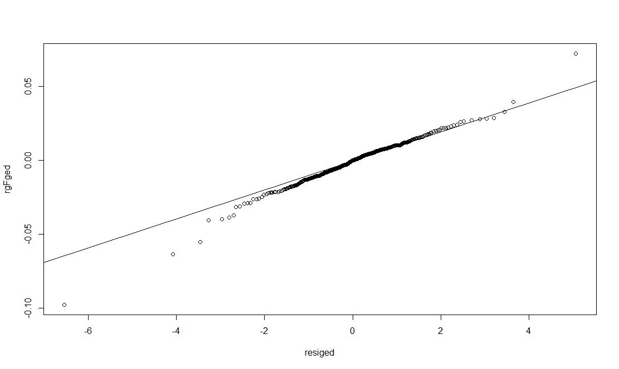

> sstdFit(rgF1)

$minimum

[1] -1530.795

$estimate

mean sd nu xi

0.0004465873 0.0129095970 3.7927380259 0.8730430515

$gradient

mean sd nu xi

0.0284479529 -0.3718106313 -0.0001347200 -0.0002689183

$code

[1] 3

$iterations

[1] 37

Warning messages:

1: In log(dsstd(y, x[1], x[2], x[3], x[4])) : NaNs produced

2: In nlm(f = loglik, p = p, y = x, ...) :

NA/Inf replaced by maximum positive value

3: In log(dsstd(y, x[1], x[2], x[3], x[4])) : NaNs produced

4: In nlm(f = loglik, p = p, y = x, ...) :

NA/Inf replaced by maximum positive value

5: In log(dsstd(y, x[1], x[2], x[3], x[4])) : NaNs produced

6: In nlm(f = loglik, p = p, y = x, ...) :

NA/Inf replaced by maximum positive value

7: In log(dsstd(y, x[1], x[2], x[3], x[4])) : NaNs produced

8: In nlm(f = loglik, p = p, y = x, ...) :

NA/Inf replaced by maximum positive value

> sh=sstdFit(rgF1)$estimate[3]; sh

Warning messages:

1: In log(dsstd(y, x[1], x[2], x[3], x[4])) : NaNs produced

2: In nlm(f = loglik, p = p, y = x, ...) :

NA/Inf replaced by maximum positive value

3: In log(dsstd(y, x[1], x[2], x[3], x[4])) : NaNs produced

4: In nlm(f = loglik, p = p, y = x, ...) :

NA/Inf replaced by maximum positive value

5: In log(dsstd(y, x[1], x[2], x[3], x[4])) : NaNs produced

6: In nlm(f = loglik, p = p, y = x, ...) :

NA/Inf replaced by maximum positive value

7: In log(dsstd(y, x[1], x[2], x[3], x[4])) : NaNs produced

8: In nlm(f = loglik, p = p, y = x, ...) :

NA/Inf replaced by maximum positive value

nu

3.792738

> sk=sstdFit(rgF1)$estimate[4]; sk

Warning messages:

1: In log(dsstd(y, x[1], x[2], x[3], x[4])) : NaNs produced

2: In nlm(f = loglik, p = p, y = x, ...) :

NA/Inf replaced by maximum positive value

3: In log(dsstd(y, x[1], x[2], x[3], x[4])) : NaNs produced

4: In nlm(f = loglik, p = p, y = x, ...) :

NA/Inf replaced by maximum positive value

5: In log(dsstd(y, x[1], x[2], x[3], x[4])) : NaNs produced

6: In nlm(f = loglik, p = p, y = x, ...) :

NA/Inf replaced by maximum positive value

7: In log(dsstd(y, x[1], x[2], x[3], x[4])) : NaNs produced

8: In nlm(f = loglik, p = p, y = x, ...) :

NA/Inf replaced by maximum positive value

xi

0.8730431

> gF2=garchFit(~arma(1,0)+garch(1,1),wd_vol,cond.dist="sstd",shape=sh,include.shape=FALSE,skew=sk,include.skew=FALSE)

Series Initialization:

ARMA Model: arma

Formula Mean: ~ arma(1, 0)

GARCH Model: garch

Formula Variance: ~ garch(1, 1)

ARMA Order: 1 0

Max ARMA Order: 1

GARCH Order: 1 1

Max GARCH Order: 1

Maximum Order: 1

Conditional Dist: sstd

h.start: 2

llh.start: 1

Length of Series: 504

Recursion Init: mci

Series Scale: 0.01296733

Parameter Initialization:

Initial Parameters: $params

Limits of Transformations: $U, $V

Which Parameters are Fixed? $includes

Parameter Matrix:

U V params includes

mu -0.29739753 0.2973975 0.02973039 TRUE

ar1 -0.99999999 1.0000000 0.03176384 TRUE

omega 0.00000100 100.0000000 0.10000000 TRUE

alpha1 0.00000001 1.0000000 0.10000000 TRUE

gamma1 -0.99999999 1.0000000 0.10000000 FALSE

beta1 0.00000001 1.0000000 0.80000000 TRUE

delta 0.00000000 2.0000000 2.00000000 FALSE

skew 0.10000000 10.0000000 0.87304305 FALSE

shape 1.00000000 10.0000000 3.79273803 FALSE

Index List of Parameters to be Optimized:

mu ar1 omega alpha1 beta1

1 2 3 4 6

Persistence: 0.9

--- START OF TRACE ---

Selected Algorithm: nlminb

R coded nlminb Solver:

0: 642.14893: 0.0297304 0.0317638 0.100000 0.100000 0.800000

1: 641.50241: 0.0297331 0.0286625 0.104008 0.109139 0.807989

2: 641.12827: 0.0297367 0.0235983 0.0926001 0.111605 0.804650

3: 640.31348: 0.0297494 0.0106596 0.0846342 0.129419 0.816638

4: 640.06250: 0.0297812 -0.00446820 0.0635805 0.131048 0.820664

5: 639.68197: 0.0298530 -0.0226075 0.0645382 0.125022 0.838553

6: 639.55257: 0.0300114 -0.0144009 0.0489736 0.117726 0.855900

7: 639.52730: 0.0300332 -0.0158262 0.0536446 0.113041 0.854065

8: 639.52616: 0.0300345 -0.0158706 0.0533622 0.112953 0.853920

9: 639.52535: 0.0300436 -0.0161624 0.0531145 0.113267 0.854378

10: 639.52332: 0.0300783 -0.0166758 0.0527073 0.112714 0.854677

11: 639.50671: 0.0308625 -0.0206189 0.0512305 0.107559 0.860303

12: 639.27432: 0.0440658 -0.00535015 0.0478229 0.102754 0.867875

13: 639.03356: 0.0572404 -0.0199797 0.0559813 0.121941 0.844779

14: 639.02347: 0.0572407 -0.0200554 0.0551896 0.121526 0.844312

15: 639.01578: 0.0572479 -0.0216192 0.0534885 0.120979 0.847578

16: 639.00971: 0.0574873 -0.0217189 0.0529261 0.120403 0.847487

17: 638.96636: 0.0650726 -0.0235308 0.0508819 0.110518 0.855703

18: 638.96167: 0.0663559 -0.0240793 0.0494364 0.112169 0.856278

19: 638.96163: 0.0661295 -0.0240232 0.0494337 0.112231 0.856342

20: 638.96162: 0.0661401 -0.0240292 0.0494326 0.112233 0.856330

21: 638.96162: 0.0661409 -0.0240294 0.0494332 0.112234 0.856329

Final Estimate of the Negative LLH:

LLH: -1551.081 norm LLH: -3.077541

mu ar1 omega alpha1 beta1

8.576711e-04 -2.402940e-02 8.312274e-06 1.122339e-01 8.563295e-01

R-optimhess Difference Approximated Hessian Matrix:

mu ar1 omega alpha1 beta1

mu -5.582765e+06 -7585.073831 -3.326721e+08 -2.638921e+04 -4.318601e+04

ar1 -7.585074e+03 -535.915722 4.816879e+04 -3.132950e+01 -4.703938e+00

omega -3.326721e+08 48168.793312 -4.397229e+11 -3.473758e+07 -5.751704e+07

alpha1 -2.638921e+04 -31.329498 -3.473758e+07 -4.428263e+03 -5.886331e+03

beta1 -4.318601e+04 -4.703938 -5.751704e+07 -5.886331e+03 -8.989489e+03

attr(,"time")

Time difference of 0.05712914 secs

--- END OF TRACE ---

Time to Estimate Parameters:

Time difference of 0.197757 secs

> summary(gF2)

Title:

GARCH Modelling

Call:

garchFit(formula = ~arma(1, 0) + garch(1, 1), data = wd_vol,

skew = sk, shape = sh, cond.dist = "sstd", include.skew = FALSE,

include.shape = FALSE)

Mean and Variance Equation:

data ~ arma(1, 0) + garch(1, 1)

<environment: 0x0000000011939e28>

[data = wd_vol]

Conditional Distribution:

sstd

Coefficient(s):

mu ar1 omega alpha1 beta1

8.5767e-04 -2.4029e-02 8.3123e-06 1.1223e-01 8.5633e-01

Std. Errors:

based on Hessian

Error Analysis:

Estimate Std. Error t value Pr(>|t|)

mu 8.577e-04 4.376e-04 1.960 0.0500 *

ar1 -2.403e-02 4.370e-02 -0.550 0.5824

omega 8.312e-06 4.211e-06 1.974 0.0484 *

alpha1 1.122e-01 4.696e-02 2.390 0.0169 *

beta1 8.563e-01 5.030e-02 17.024 <2e-16 ***

---

Signif. codes: 0 ・**・0.001 ・*・0.01 ・・0.05 ・・0.1 ・・1

Log Likelihood:

1551.081 normalized: 3.077541

Description:

Fri Apr 22 20:56:17 2016 by user: Jonathan!

Standardised Residuals Tests:

Statistic p-Value

Jarque-Bera Test R Chi^2 12664.39 0

Shapiro-Wilk Test R W 0.8657818 0

Ljung-Box Test R Q(10) 11.43325 0.3247746

Ljung-Box Test R Q(15) 14.28772 0.5038295

Ljung-Box Test R Q(20) 19.06954 0.5173103

Ljung-Box Test R^2 Q(10) 0.5660555 0.999988

Ljung-Box Test R^2 Q(15) 2.795261 0.9997414

Ljung-Box Test R^2 Q(20) 2.910903 0.9999968

LM Arch Test R TR^2 2.531255 0.9980454

Information Criterion Statistics:

AIC BIC SIC HQIC

-6.135242 -6.093351 -6.135436 -6.118809

> rgF2=residuals(gF2)

> set.seed(6737)

> resi2=rsstd(9000,nu=sh,xi=sk)

> qqplot(resi2,rgF2)

> qqline(rgF2,distribution=qsstd)

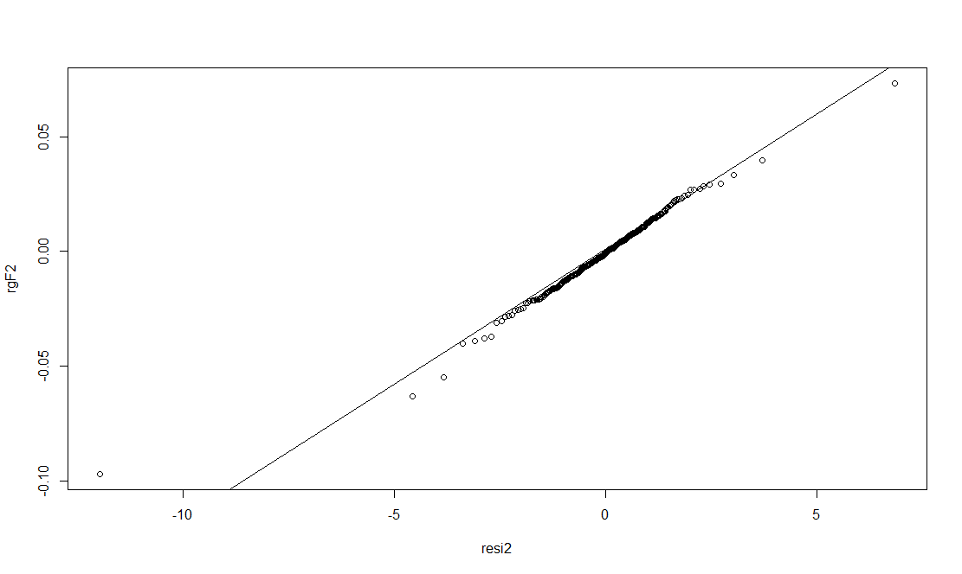

> predict(gF2,n.ahead=5,trace=TRUE,plot=FALSE)

Model Parameters:

mu ar1 ma1 omega alpha1 gamma1

8.576711e-04 -2.402940e-02 0.000000e+00 8.312274e-06 1.122339e-01 0.000000e+00

beta1 delta skew shape

8.563295e-01 2.000000e+00 8.730431e-01 3.792738e+00

Forecast GARCH Variance:

Forecast ARMA Mean:

Call:

arima(x = object@data, order = c(max(u, 1), 0, max(v, 1)), transform.pars = FALSE,

init = c(ar, ma, mu), optim.control = list(maxit = 0))

Coefficients:

ar1 ma1 intercept

-0.024 0 8e-04

s.e. NaN NaN 6e-04

sigma^2 estimated as 0.0001684: log likelihood = 1474.55, aic = -2941.09

$pred

Time Series:

Start = 505

End = 509

Frequency = 1

[1] 0.0009158121 0.0008356647 0.0008375906 0.0008375443 0.0008375454

$se

Time Series:

Start = 505

End = 509

Frequency = 1

[1] 0.01297634 0.01298009 0.01298009 0.01298009 0.01298009

meanForecast meanError standardDeviation

1 0.0009158121 0.009695078 0.009695078

2 0.0008356647 0.009970266 0.009967544

3 0.0008375906 0.010227332 0.010224525

4 0.0008375443 0.010470300 0.010467415

5 0.0008375454 0.010700371 0.010697413

Warning message:

In sqrt(diag(x$var.coef)) : NaNs produced

> c=rep(0,5)

> c=predict(gF2,n.ahead=5,trace=FALSE,plot=FALSE)$meanForecast

> wd_vol_pred=c(wd_vol,c)

> wd_ts_log=c(log(wd_ts[1]),log(wd_ts[1])+cumsum(wd_vol_pred))

> wd_ts_pred=exp(wd_ts_log)

> y_hat=wd_ts_pred[(length(wd_ts_pred)-4):(length(wd_ts_pred))]

> y_hat

[1] 99.16077 99.24367 99.32683 99.41006 99.49335

> y=c(98.68,97.00,97.48,96.16,96.42); y

[1] 98.68 97.00 97.48 96.16 96.42

> cor(y_hat,y)

[1] -0.8487504